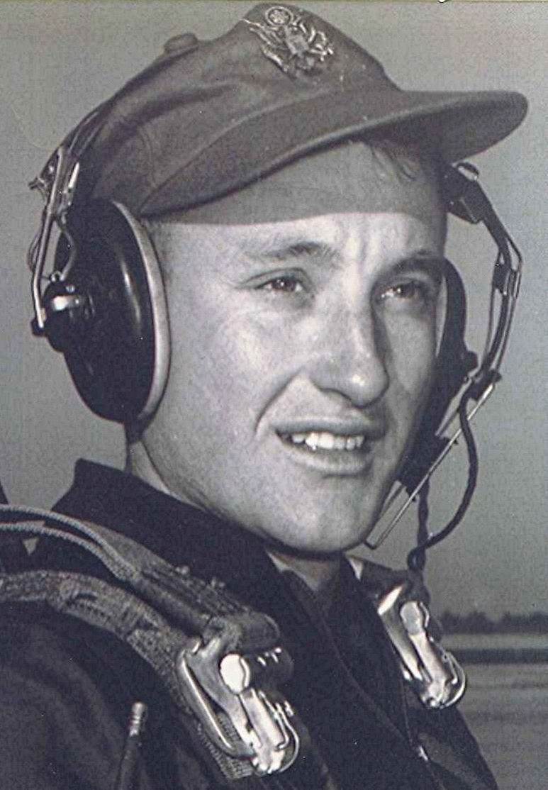
Looking Back, April 27, 1999
Old memories awakened, of times past, seen through a filter that spares us the realities that really were back then. Replaced now by a softer view of what was and what we were.

I. M. Squatley, Amateur Philosopher, Dyer Arkansas
Class of ‘51

Notes and Opinions
Looking into the abyss
A Tuesday:
Events of the past week at Littleton, Colorado, have caused some, I assume, to think about good and evil and the titanic struggle that goes on. There are some of us who have lived long enough to have a memory of the times when such horrors would have been unthinkable. Today we wait for the next one to happen, whether tomorrow or next month. Most of our own kids grew up in a time when doing your own thing and letting it all hang out were the by-words of the day. All convention having been cast aside in the revolution lead by sandal clad academics and long-haired drug gurus. Charles Manson’s crowd was a precursor of things to come, and now they are here.
We learned from Dr. Spock, who incidentally had none of his own, how to raise kids unfettered by the normal strictures of discipline we encountered back when Peach Tree switches and, in my case, hunting horn straps were part of our education. Now Spock’s kids have kids of their own, and we are seeing the results. Imagine a world where you are ushered in by Dr. Spock and ushered out by Dr. Kevorkian. That is, if you make it that far without encountering some sixteen year old with a grudge, an Uzzi, and several full clips of ammunition.

God Help Us.

